**APPROVED**

The Logic Luminaries Enterprise

Software QA department manager

John Doe

**REVIEWED**

The Logic Luminaries Enterprise

Software Development manager

Tretta Gumberg

**SOFTWARE QUALITY ASSURANCE BUG REPORTING PROCESS**

The purpose of this document is to ensure quality of the end product of the company by the following process of creating bug reports for any of the company software.

Ensure all the reports and associated data (attachments, screenshots, source videos) are uploaded and stored only on the company’s [JIRA](https://JIRA.com/) and/or company’s localhost server.

In any case of access issues with accessing the company [JIRA](https://JIRA.com/), contact your team lead or create a helpdesk ticket at [HELPME](mailto:help@me.com?subject=NOTHING%20WORKS,%20I%20CANT%20WORK,%20DO%20SOMETHING!!1) portal.

Prior to commencing any testing activities make sure to get acquainted with the current document and all the accompanying documentations stored at the dedicated [SharePoint.](https://Sharepoint.com/)

For creation of a bug report, the tester shall follow these steps:

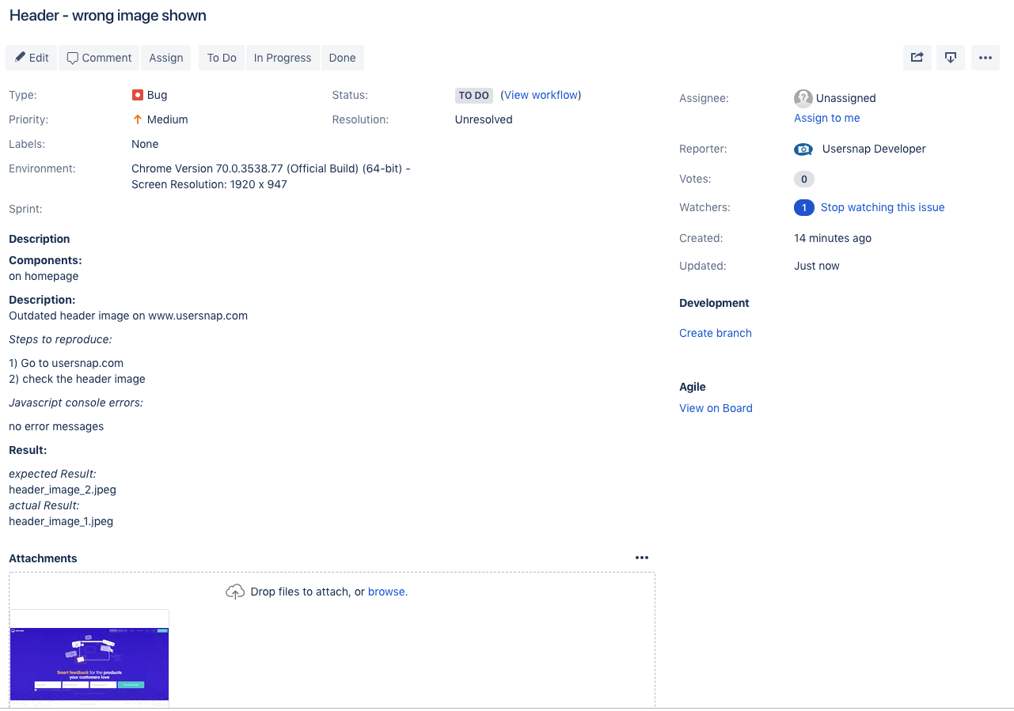

A Sample Bug report made with JIRA

*Bermin J 2024, usersnap, digital image, ALIEM, accessed 18 February 2024, <https://usersnap.com/blog/bug-report-template/>*

The team leads shall vet all the reports and reassign them to the development team lead with a [VETTED] status.

The development team lead distributes the reports to the developers for resolving, or, in case of lack or unclear information creates a new testing case for the testing team.

All the [RESOLVED] reports shall be regressed in order.

Testing is deemed as ongoing, until there are any tickets with no [CLOSED] status.

Accountability matrix:

|  |  |
| --- | --- |
| Creation of bug reports | Tester |
| Reports vetting | Testing lead |
| Submission of reports to the dev team | Testing lead |
| Bug resolution | Development team software engineer |
| Confirmation testing (Regression) | Tester |
| Closing the report | Dev team lead |

Sample of a ‘good’ ticket:

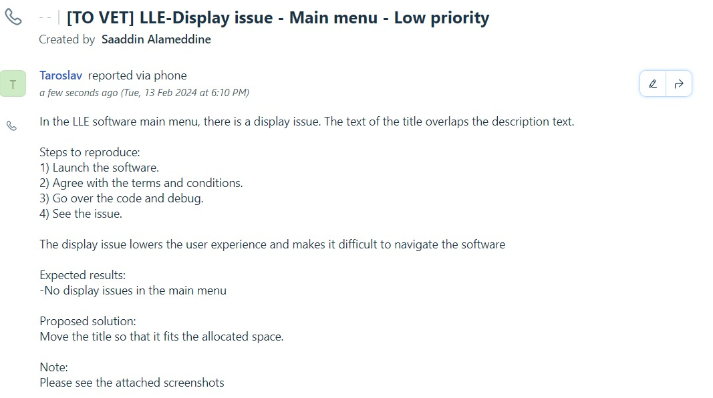

Revision History:

|  |  |  |  |
| --- | --- | --- | --- |
| Date | Revision Description | Version | Author |
| 2024-02-12 | Initial creation of the document. | 1.0 | John Doe |
| 2024-02-15 | Updated roles and responsibilities in the accountability matrix | 1.1 | Jane Smith |
| 2024-02-20 | Added contact information for team members. | 1.2 | Emily Johnson |

**Quality Assurance Testing Team Lead Adam Smith**

Link to the repo: <https://github.com/matineno/TWS-Repo/tree/main/final-project-logical-luminaries